Child’s Name: |  | Team:
Parent’s Name: |  | Date:
Email: |  | Contact No.

Item | Description | Sizes  Available | Price | Size  Ord | Qty  Ord | Sub  Total
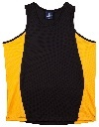 | Training Singlet | 6,8,10,12,14  XS, S, M, L  XL,2XL, 3XL | $20
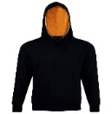 | Hoodie | 6,8,10,12,14  XS, S, M, L  XL,2XL, 3XL,5XL | $40
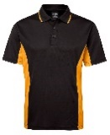 | Polo Shirt | 6,8,10,12,14  XS, S, M, L  XL,2XL, 3XL,4XL,5XL | $30
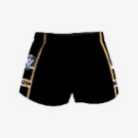 | Shorts (AFL Country Approved) | 3XS, 2XS, XS, S, M, L, XL, XXL, 3XL, 4XL | $35
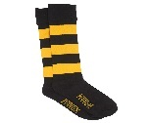 | Socks | 2-7,  6-10,  11-14 | $10
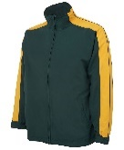 | Warm up Jacket | 8,10,12,14  XS, S, M, L  XL,2XL | $45
 | Beanie | One size | $20
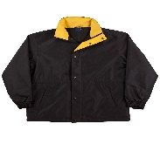 | Racing Jacket | XS, S, M, L  XL, 2XL, 3XL | $65
 | Umbrella | N/A | $40
Amount Payable $_________

Direct Debit details Payment Details: Payment Status:
Seaford JFC Cash / Credit Card / Eftpos PAID IN FULL BSB 063-492 COD Acc no. 1034 5463 OTHER: ______________________

