Seaford Junior Football Club Est 1971
S
  - Sponsorship Packages 2024
Where young tigers learn to roar
About our club

Support the most successfully run football club
Seaford Junior Football Club is recognised as the benchmark throughout the football industry and has obtained the following achievements.
| Bronze, Silver, and Gold accreditation in Football Victoria’s “Quality Club Program” and still remains the only club with Gold accreditation | Winner of Community Club of the Year in 2006 | Finalist in Vic Sports 2007 Club of The Year Award | Winner of 2007 Goods Sports Southeast Region Club of the Year | Runners Up of 2007 Goods Sport Victorian Club of the Year |

Seaford Junior Football Club was established in 1971 and have headquarters located at Belvedere Reserve, East Road.
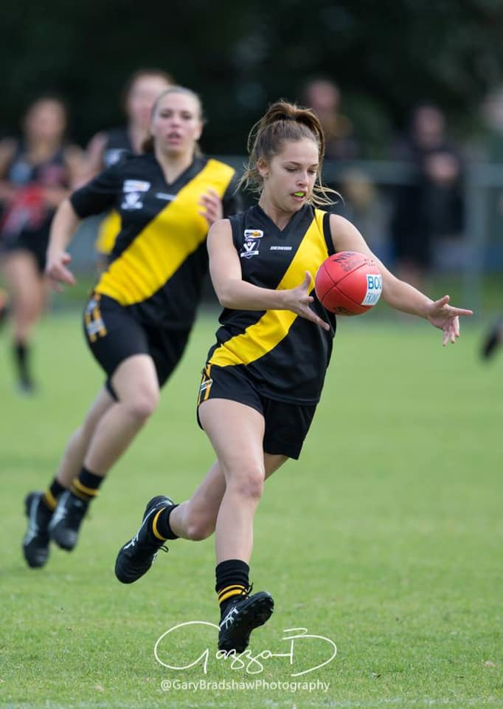
The club has approximately 400 players participating in Junior Football, 100 Seaford Auskickers and approximately 100 cricketers both junior and senior during the summer season. Come and be a part of the Club that produced dual Brownlow Medallist, Robert Harvey as well as former AFL players Jack Lonie, Mitch White, Liam Hullet, and current players Aiden Bona, and AFLW players Courtney Jones, and Molly McDonald.
Although we can boast of relative on-field success in past seasons we have the greater responsibility of participation and encouragement; hence our Mission Statement: “To provide the youth of Seaford and surrounding areas with the opportunity to participate in structured formal activities to help develop their self-esteem, football and social skills in a supporting environment.”

We have 16 competitive teams ranging from Under 9’s to Under 18’s playing each Sunday in the football season. We also have two girls’ only teams which, with the AFL women’s League growing each season and being the fastest growing demographics at the moment it’s certainly exciting times for the girls in footy.
With 14 games on average and training every night of the week at the ovals, we attract not only Seaford families and their supporters but also visiting teams from Mordialloc right through to Sorrento.
Sponsorship Packages
PLATINUM  $3,500 Excludes GST (2x available)  Boundary signage x 2 in a prominent position on ovals 2 & 3 that will be seen every day of the year.  Tear drop banner displayed out the front of clubhouse game days and SJFC events.  Scoreboard business logo displayed on electric scoreboard at ovals 2 & 3.  Website business logo on website home page and on sponsor page with a blurb & details.  Facebook, we promote your business through sponsor of the week and match reports to our 1.8k followers.  Tickets 4x to all club fundraising events includes  4x complimentary drinks.  Tickets 4x to the night of the tiger.  Speaking opportunity at night of the tiger.  Business Card on wall of clubhouse.  Clubhouse wall banner business logo displayed on wall banner in clubhouse throughout season.  Merchandise complimentary club polo shirt and club jacket.  Club email business logo featured in email signature.  Club letterhead business logo featured on club letterhead.  Sponsorship plaque  Sponsorship is a vital part of the success of the Seaford Junior Football Club |  | GOLD  $2,000 Excludes GST (5x available)  Boundary signage x 2 on ovals 2 & 3 that will be seen every day of the year.  Scoreboard business logo displayed on electric scoreboard at ovals 2 & 3.  Website business logo on sponsor page with a blurb & details.  Facebook, we promote your business through sponsor of the week and match reports to our 1.8k followers.  Tickets 2x to all club fundraising events includes  2x complimentary drinks.  Tickets 2x to the night of the tiger.  Business Card on wall of clubhouse.  Clubhouse wall banner business logo displayed on wall banner in clubhouse throughout season.  Merchandise complimentary club polo shirt.  Sponsorship certificate
Sponsorship Packages
SILVER  $1,000 Excludes GST (unlimited)  Boundary signage on main oval that will be seen every day of the year.  Scoreboard business logo displayed on electric scoreboard at ovals 2 & 3.  Website business logo on sponsor page with a blurb & details.  Facebook, we promote your business through sponsor of the week and match reports to our 1.8k followers.  Tickets 2x to the night of the tiger.  Business Card on wall of clubhouse.  Clubhouse wall banner business logo displayed on wall banner in clubhouse throughout season.  Sponsorship certificate |  | BRONZE  $500 Excludes GST (unlimited)  Scoreboard business logo displayed on electric scoreboard at ovals 2 & 3.  Website business logo on sponsor page with details.  Facebook, we promote your business through sponsor of the week and match reports to our 1.8k followers.  Tickets 2x to the night of the tiger.  Business Card on wall of clubhouse.  Clubhouse wall banner business logo displayed on wall banner in clubhouse throughout season.  Being a sponsor is a great way to promote your business and support youth in the local community.
The funds raised will be used to purchase equipment and to further improve our facilities for players and supporters.

Please note: All packages exclude GST
2024 Seaford JFC Sponsorship Application Form

Sponsor name: _____________________________________________
Contact: Mark Davenport
Seaford Junior Football Club
M: 0435 900 674
E: sponsorship@seafordjfc.com.au

Sponsor ABN: _____________________________________________
Contact name: _____________________________________________
Address: __________________________________________________
Email: __________________________________________________
Phone: __________________________________________________

Sponsorship type: Platinum $3,500 Gold $2,000 Silver $1,000 Bronze $500

Contribution: $____________________
We look forward to having you
on board 2024
Thank you for supporting
Seaford Junior Football Club.
GST: $____________________
Total: $____________________

Date of Agreement: ______/________/ 2024 Payment Method: ____________________
Signature: ____________________ Receipt No.: (club use only) ____________________
ABN 26 579 917 941 | PO Box 54 Seaford VIC 3198 | Website: www.seafordjfc.com.au | Facebook: Seaford Junior Football Club
2024 Seaford JFC Sponsorship Contract

All sponsorships commence on April 1st, 2024, and expire on 31st March 2025. You will be notified of renewal (optional) in Feb/Mar the following year.

Payment should be made within 14 days of receipt of invoice and payment cleared by Monday 25th March 2024.

Orders for boundary signage and clubhouse wall banners will be placed on Tuesday 26th March 2022 to have signage erected the week following April 1st.

Sign Costs are incorporated, to a certain level. Should your sponsorship sign have specific requirements, a contribution to this cost, on your part may be requested.

Size of signs are approx. 2440mm x 1100mm and material used is Corflute.

All signs remain the property of Seaford Junior Football Club Inc.

The Club reserves the right to prohibit certain products e.g.: Tobacco & products not conducive to junior sports.

On conclusion of the contract period the sponsors sign option will be offered a subsequent future renewal of sponsorship.

On completion of contract permission is granted for copyright.

